Reduced kinetic mechanism for n-pentanol flame modeling

Jaime Tiburcio-Cortés¹, Juan C. Prince-Avelino ^{1, *}, Mario Díaz-González²

¹Engineering and Science School, Tecnológico de Monterrey, México. Email: A00835449@tec.mx
1 Engineering and Science School, Tecnológico de Monterrey, México. Email: jcprince@tec.mx
2 Chemical and Biochemical Engineering Division, TNM/InstitutoTecnológico de Veracruz, México. Email: mario.dg@veracruz.tecnm.mx

Abstract

A reduced mechanism of n-pentanol was developed for application to flame modeling and simulation. The kinetic scheme consists of 12 reactions and 6 chemical species that were added to the reduced mechanism of San Diego that does not contain this fuel, resulting in a mechanism of 276 reactions and 63 chemical species. To develop it, a systematic reduction of chemical species and reactions with sensitivity analysis and steady-state approximation was applied to a detailed mechanism. The effectiveness of the reduced mechanism was corroborated with flame velocity simulations for experiments reported at a pressure of 1 bar and temperatures of 353 K, 393 K, 423 K and 433 K. For all cases, good agreement was found between the simulation results and the experimental data, with an average discrepancy of around 7%.

Keywords: Flames; n-pentanol; reduced mechanism; modeling.

Resumen

Se desarrolló un mecanismo reducido de n-pentanol para aplicarlo en el modelado y simulación de llamas. El esquema cinético consiste de 12 reacciones y 6 especies químicas que fueron adicionadas al mecanismo reducido de San Diego que no contiene este combustible, resultando un mecanismo de 276 reacciones y 63 especies químicas. Para desarrollarlo, a un mecanismo detallado se aplicó una reducción sistemática de reacciones y especies químicas con análisis de sensibilidad y aproximación de estado estacionario. Se corroboró la efectividad del mecanismo reducido con simulaciones de velocidad de llamas para experimentos reportados a una presión de 1 bar y temperaturas de 353 K, 393 K, 423 K y 433 K. Para todos los casos se encontró buena concordancia de los resultados de la simulación con respecto a los datos experimentales con una diferencia media relativa de 7 %.

Palabras clave: Llamas; n-pentanol; mecanismo reducido; modelado.

Introduction

Energy sources are essential for the global development of countries and the world. Currently, the energy produced by the combustion of natural gas, oil and derivatives, coal, and other materials called “fossil fuels” represents at least three quarters of total energy consumed throughout the planet.

A consequence of these combustion processes is the generation of greenhouse gases (carbon dioxide and carbon monoxide, methane, nitrogen oxides, sulfur dioxide, ozone and water steam) which are determining factors of climate change. Likewise, dwindling reserves of conventional fossil fuels, the growing global demand for energy and the need to move towards energy independence require the use of renewable biofuels that balance their long-term availability and ecological impact without compromising the operation and performance of combustion systems. For example, the International Energy Agency, since 2011, has focused on promoting using biofuel mixtures in the transport sector, such as biodiesel, proposing a goal of increasing its global consumption, for the year 2050, up ten times more than the current level [1].

Alcohols, derived from biochemical processes, have potential to produce fuels that, in addition to being renewable, produce cleaner combustion. Furthermore, many of their physical-chemical properties are compatible with operation requirements of modern engines, which does them attractive, either as partial or total surrogates for fossil fuels or as additives.

In recent years biofuels n-pentanol and its isomers have been tested on internal combustion engines as they are considered possible alternatives to fossil fuels. A study by Heufer et al. [2] suggests that the reactivity of alcohols with longer carbon chains is equivalent to that of their corresponding alkanes. On the other hand, compared to low-carbon alcohols, n-pentanol has higher energy density, higher boiling point, lower hygroscopicity, and lower corrosivity [3].

An important parameter applied for characterize combustion processes and estimate emissions produced by fuel-air mixtures considering different conditions is flame speed. The study of flame speed provides relevant information about reactivity, thermal diffusivity and exothermicity of fuels. Flame speed is also used to validate chemical kinetic mechanisms, to develop new mechanisms, and calculate turbulent combustion rates. A fuel with a higher flame speed can relieve the requirements of complex injection patterns to increase the intensity of turbulence [4]. For a given mixture of fuel and oxidant, flame speed depends on initial pressure, unburned mixture temperature and the equivalence ratio. Gautam et al. [5] conducted experimental investigations on the combustion characteristics of gasoline and gasoline blended with alcohols (n-propanol, n-butanol, and n-pentanol). This study indicates that alcohol/gasoline blends show a higher flame speed compared to pure gasoline, mainly due to the increased oxygen content in the blend due to the presence of alcohol.

In the literature there are four outstanding studies that are widely referred to and that report the experimental measurement of the flame speed for mixtures of n-pentanol and air [3,6-8]. Togbe et al. [6] measured laminar flame speed using spherical expansion flame method by applying a nonlinear correlation for stretch correction presented by Kelly and Law [9]; measurements were made at 423 K and 1.0 atm and equivalence ratios, φ, in a range from 0.7 to 1.4. Li et al. [7,8] presented two studies for mixtures of n-pentanol and air also using spherical expansion flame method for a pressure range from 1.0 to 7.5 bar, initial temperatures of 393 K, 433 K and 473 K and φ in a range from 0.6 to 1.8. In their first study [7] these researchers reported burning rates using a linear extrapolation model of the stretched flame speed to zero stretch. In their second study [8] the speed of unstretched flame was evaluated using a nonlinear expression proposed by Kelly et al. [10] for same temperature and pressure conditions. Nativel et al. [3] applied the same spherical expansion flame method for mixtures of n-pentanol and air at temperatures of 353 K, 433 K and 473 K, pressure of 1.0 bar and φ in a range from 0.7 to 1.5. In last decade, the development of kinetic combustion mechanisms for n-pentanol in mixtures with air and other fuels has been addressed with great interest. Table 1 summarizes the most outstanding studies published from 2011 to date, of which 8 correspond to detailed mechanisms and 5 to reduced mechanisms.

Table 1. Combustion kinetic mechanisms for pentanol and its isomers published 2011-2022.

Item | Fuels and Mixtures | Detailed mechanisms |  | Reduced mechanisms |  | Researchers | Year | Ref.
 |  | Species | Reactions | Species | Reactions
1 | 1-pentanol | 261 | 2099 |  |  | Togbé et al. | 2011 | [6]
2 | n-pentanol | 599 | 3010 |  |  | Heufer et al. | 2012 | [2]
3 | 1,2,3 pentanol | 169 | 1346 |  |  | Li et al. | 2013 | [7]
4 | 1,2,3 pentanol | 225 | 24526 |  |  | Kohler et al. | 2015 | [11]
5 | n-pentanol | 314 | 1602 |  |  | Wang et al. | 2015 | [13]
6 | n- and isopentanols | 230 | 7885 |  |  | Nativel et al. | 2016 | [3]
7 | C₁-C₅ alcohols |  |  | 161 | 622 | Liu et al. | 2016 | [12]
8 | n-pentanol | 298 | 11095 |  |  | Pelucchi et al. | 2017 | [14]
9 | Diesel/biodiesel/n-pentanol |  |  | 229 | 902 | Ma et al. | 2018 | [15]
10 | Diesel/pentanol |  |  | 178 | 746 | Huang et al. | 2018 | [16]
11 | n-pentanol |  |  | 199 | 1427 | Katoch et al. | 2019 | [17]
12 | nC₁-C₆ | 491 | 17888 |  |  | Pelucchi et al. | 2020 | [18]
13 | n-pentanol |  |  | 148 | 575 | Li et al. | 2021 | [19]

Source: Authors’ own elaboration

Consequently, it is observed that the study of combustion of n-pentanol is a research field in early development. The objective of present work is to develop a reduced kinetic mechanism for combustion of n-pentanol in order to apply it in modeling and simulation of flames. For this purpose, systematic reduction of reactions and chemical species is applied through sensitivity analysis and steady state approximation. The effectiveness of developed reduced mechanism is corroborated by comparing results of simulations against reported experimental data [3,6-8].

Development of reduced kinetic model.

For development of reduced kinetic model for simulation of flames for n-pentanol, skeletal mechanism of the University of California, San Diego, known as San Diego mechanism (SD mech) [20,21], is taken as a basis. This mechanism consists of 57 chemical species and 264 reactions and includes up to the C₄ hydrocarbon, n-butane [21]. On the other hand, detailed kinetic model for combustion of n-pentanol proposed by Heufer et al. [2] with 599 chemical species and 3010 reactions is considered. From this mechanism, species and reactions corresponding to high temperature kinetics (T > 1000 K), which is where flame phenomenon develops, were investigated and selected, in order to couple them to San Diego base mechanism. Subsequently, through systematic reduction of reactions and chemical species applying sensitivity analysis and steady state approximation, 6 species and 12 reactions are identified that, added to the SD mechanism, allow integrating a kinetic reduced mechanism. This mechanism generates flame speed results with good agreement respecting to experimental data reported by the studies that have been considered as references in the last decade [3,6,7]. The generated model, considering the species and reactions of SD mech, finally consists of 63 chemical species and 276 reactions. It is important to emphasize that no chemical parameter was chosen arbitrarily to fit experimental data and all of them have been taken as they are in literature.

Table 2. Reduced set of chemical reactions for n-pentanol added to San Diego mechanismª.

Num. | Reactions | B | n | E_{a}
R₁ | C₅H₁₁OH (+M) C₂H₅ + C₃H₆OH-3 (+M)  Low pressure limit: 0.8025E+114 -0.2765E+002 0.9645E+005  TROE centering: 0.9703E-004 0.2684E+003 0.2684E+003 0.4740E+004 | 3.082E+24 | -2.269 | 8.844E+04
R₂ | C₅H₁₁OH (+M) PC₄H₉ + CH₂OH (+M)  Low pressure limit: 0.1416E+060 -0.1193E+002 0.8398E+005  TROE centering: 0.7646E+000 0.8344E+010 0.7248E+003 0.8214E+010 | 3.020E+23 | -1.880 | 8.571E+04
R₃ | C₅H₁₁OH + H C₅H₁₀OH-11 + H₂ | 8.789E+04 | 2.680 | 2.915E+03
R₄ | C₅H₁₁OH + OH C₅H₁₀OH-11 + H₂O | 3.610E+03 | 2.890 | -2.291E+03
R₅ | C₅H₁₁OH + HO₂ C₅H₁₀OH-11 + H₂O₂ | 3.500E-05 | 5.260 | 8.268E+03
R₆ | C₅H₁₀OH-11 + O₂ NC₄H₉CHO + HO₂ | 3.780E+20 | -2.429 | 3.090E+03
R₇ | NC₄H₉CHO + H C₅H₁₀OH-11 | 8.000E+12 | 0.000 | 9.500E+03
R₈ | NC₄H₉CHO + H NC₄H₉CO + H₂ | 4.140E+09 | 1.120 | 2.320E+03
R₉ | NC₄H₉CHO + OH A-C₃H₅CHO + CH₃ +H₂O | 4.670E+07 | 1.610 | -3.5E+01
R₁₀ | NC₄H₉CO PC₄H₉ + CO | 1.000E+11 | 0.000 | 9.600E+03
R₁₁ | A-C₃H₅CHO + OH C₃H₅ +CO +H₂O | 2.690E+10 | 0.760 | -3.40E+02
R₁₂ | C₃H₆OH-3 C₂H₄ + CH₂OH | 4.231E+10 | 1.035 | 2.8170E+04

ª With corresponding units, B [mol-cm-s-K], E_{a} [cal/mol]; “n” is a dimensionless parameter.
Source: Authors’ own elaboration

The development of reduced mechanism was carried out with support of FlameMaster code [22]. Table 2 shows reduced kinetic mechanism proposed in this study with corresponding reaction rate parameters according to modified Arrhenius equation:

(1)

Where B is a constant parameter independent of temperature; T, is temperature in Kelvin; n is a constant parameter, E_{a} is activation energy and R, is universal ideal gas constant.

Table 2 shows that 6 new species are added to the SD mech involved in these 12 reactions: C₅H₁₁OH, n-pentanol; C₃H₆OH-3, hydroxypropyl radical; C₅H₁₀OH-11, hydroxypentil radical; NC₄H₉CHO, pentanal; NC₄H₉CO, keto-butyl radical and A-C₃H₅CHO, butenal.

This kinetic mechanism can be summarized as follows: it begins with decomposition of fuel, n-pentanol, represented by reactions R₁ and R₂, since for these the dissociation energy required to break C-C bonds is lowest for this alcohol. For R₁ reaction, 88 Kcal/mol are required to break C_{α}-C_{δ} bond and for R₂ reaction, 86.8 Kcal/mol are required to break C_{α} - C_{β} bond [18]. The ethyl radical (C₂H₅) and hydroxypropyl radical (C₃H₆OH-3) are produced from R₁ reaction, and butyl radical (PC₄H₉) and hydroxymetyl radical (CH₂OH) are produced from the R₂ reaction. The hydroxypropyl radical produced in R₁ reaction decomposes in R₁₂ reaction into ethene or ethylene (C₂H₄) and into hydroxymethyl radical (CH₂OH). Reactions R₃, R₄ and R₅ represent the attack of n-pentanol by monatomic hydrogen (H), hydroxyl radical (OH) and hydroperoxy radical (HO₂), to produce, in all three cases, hydroxypentyl radical (C₅H₁₀OH- 11) and also diatomic hydrogen, water and hydrogen peroxide, respectively. In the process of development reduced mechanism, it has been observed that radical C₅H₁₀OH-11, also called α-C₅H₁₀OH, is the most important for flame generation and is also the one with lowest bond dissociation energy [2], so it is considered to represent the nC₅H₁₀OH radicals that involve five isomers of this type of chemical species. In R₆ reaction, hydroxypentyl radical reacts with molecular oxygen (O₂) to form pentanal (NC₄H₉CHO), what is the compound from which flame generation process begins. NC₄H₉CHO reacts with H to produce C₅H₁₀OH-11 (R₇), that is, a cycle is established between R₆ and R₇ reactions. This NC₄H₉CHO cycle competes with two other reactions that consume pentanal (R₈ and R₉ reactions). In R₈ reaction, pentanal reacts with H to form the keto-butyl radical (NC₄H₉CO), and in R₉ reaction, pentanal reacts with OH to produce butenal (A-C₃H₅CHO). Butenal reacts with OH in R₁₁ reaction to produce allyl radical (C₃H₅), CO, and water. The keto-butyl radical (NC₄H₉CO) decomposes in R₁₀ reaction to generate butyl radical (PC₄H₉) plus CO. Reactions R9 and R11 have been derived by applying a steady state approximation to eliminate two chemical species given that they are consumed at least at same speed which they are produced. The generated reduced kinetic mechanism is shown schematically in Figure 1.

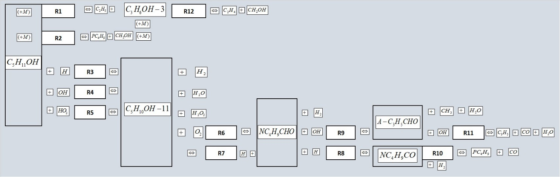

Figure 1. Schematic representation of reduced kinetic mechanism.
Source: Authors’ own elaboration

By reaction flow analysis carried out with FlameMaster [22], the portions in which chemical species are consumed and produced are determined. This flow analysis is shown in Table 3 for n-pentanol, hydroxypentyl radical and pentanal which are three important species through which mechanism flows.

For n-pentanol, main consumption reactions are reactions with OH (R₄, 50.70%) and with H (R₃, 46.74%) and it is verified that decomposition reactions R₁ and R₂ consume a very low portion of fuel. For hydroxypentyl radical, main consumption pathway is R₇ reaction (59.35%), although this has been considered as a production pathway for this radical and not consumption, so this R₇ reaction favors the production of pentanal and H which is an important factor in flame speed. On the other hand, R₆ reaction is other important pathway of consumption of hydroxypentyl radical (40.65%). Respecting to production of hydroxypentyl, main pathways are R₄ (51.94%) and R₃ (47.88%) reactions. For pentanal, main consumption pathway is reaction R₈ with H (60.60%), followed by reaction R₉ with OH (39.40%). The pentanal production pathways are R₇ (59.35%) and R₆ (40.65%) reactions.

Table 3. Reaction flow pathways for n-pentanol, hydroxypentyl radical and pentanal.

Step | C₅H₁₁OH |  | C₅H₁₀OH-11 |  | NC₄H₉CHO
 | Reaction | % | Reaction | % | Reaction | %
Consumption | R₄ | 50.70 | R₇ | 59.35 | R₈ | 60.60
 | R₃ | 46.74 | R₆ | 40.65 | R₉ | 39.40
 | R₁ | 1.74
 | R₂ | 0.63
 | R₅ | 0.18
Total |  | 100.00 |  | 100.00 |  | 100.00
Production |  |  | R₄ | 51.94 | R₇ | 59.35
 |  |  | R₃ | 47.88 | R₆ | 40.65
 |  |  | R₅ | 0.18
Total |  |  |  | 100.00 |  | 100.00

Source: Authors’ own elaboration

To analyze the influence of the kinetic mechanism on n-pentanol flame, sensitivity coefficients shown in Figures 2 and 3 are calculated. It is observed that reactions that have greatest influence on flame speed, regardless of initial pressure (p) and temperature conditions (p = 1.0 bar; T= 353 K, 393 K and 433 K) are: H + O₂ OH + O, CO + OH CO2 + H and the reactions of fuel with radical OH (reaction R₄) and with hydrogen H (reaction R₃). From the above, it can be seen that kinetics that govern generation of flame is limited to hydrogen submechanism, as reported by Nativel et al. [3].

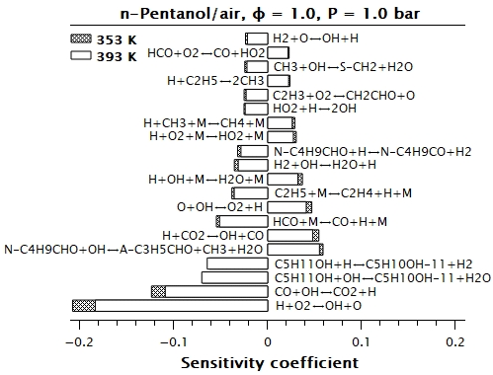

Figure 2. Sensitivity coefficients for mixture n-pentanol/air; for φ=1.0, p = 1.0 bar, T =353 K y T =393 K.
Source: Authors’ own elaboration

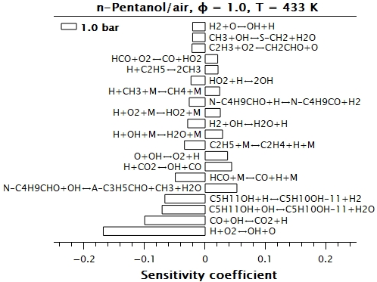

Figura 3. Sensitivity coefficients for mixture n-pentanol/air; for φ=1.0, p = 1.0 bar y T= 433 K.
Source: Authors’ own elaboration

Results

Figures 4 to 7 show comparative graphs between experimental data and results calculated from simulation of flame speeds generated by applying developed reduced kinetic mechanism. Flame speed values, S_{L}⁰, are located on the vertical axis, and are expressed in cm/s. Equivalence ratio values, φ, are located on the horizontal axis.

Figure 4 shows the comparison between experimental data and results generated from simulation of flame speeds for p = 1.0 bar and T = 353 K. It is observed that, for these conditions, results from simulation have high agreement regarding to experimental data reported for 0.8 ≤ φ ≤1.3 [3]. Mean relative difference considering the linearized experimental data is 1.78% and mean absolute difference is 0.82 cm/s. Respecting to non-linearized experimental data, mean relative difference is 1.26% and mean absolute difference is 0.60 cm/s. Jointly, this represents a mean relative difference of 1.52% and a mean absolute difference of 0.71 cm/s.

The case for a p = 1.0 bar T = 393 K is shown in Figure 5. For these conditions, mean relative difference between results from simulation and experimental data [7] is 11.84% and mean absolute difference is 3.44 cm/s, for 0.7 ≤ φ ≤ 1.8. It is observed that there is a good concordance between results from simulation and experimental data for 0.7 ≤ φ ≤ 1.0 (mean relative difference of 3.31% and mean absolute difference of 1.47 cm/s). Highest differences between results from simulation and experimental data are presented for φ > 1.1 (mean relative difference of 16.11% and mean absolute difference of 4.42 cm/s). Moreover, it should be noted that even in the region of highest difference between calculated values from simulation and experimental data, proposed reduced kinetic mechanism models very well the behavior trend of the experimental data.

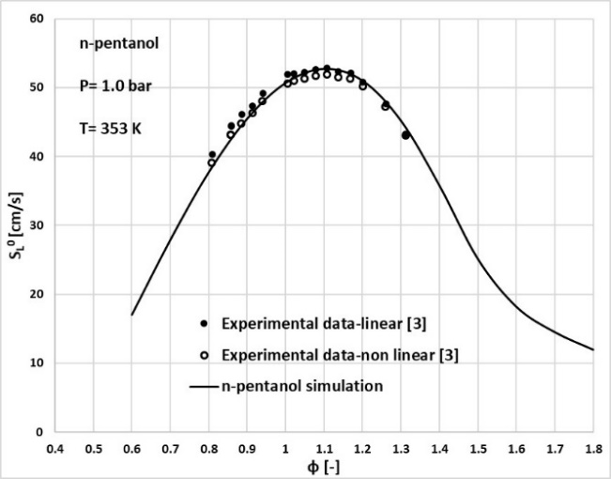

Figure 4. Experimental data and laminar flame speed simulation for n-pentanol/air mixture, p = 1.0 bar, T = 353 K. Experimental data: symbols; simulation: line.
Source: Authors’ own elaboration

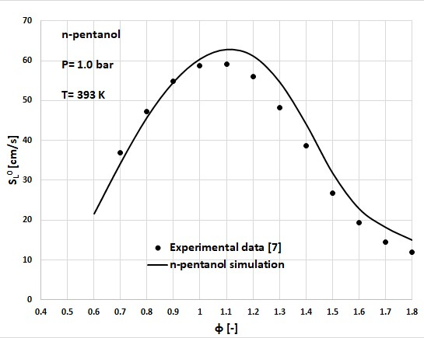

Figure 5. Experimental data and laminar flame speed simulation for n-pentanol/air mixture, p = 1.0 bar, T = 393 K. Experimental data: symbols; simulation: line.
Source: Authors’ own elaboration

Figure 6 compares results from simulation and experimental data [6] for a p = 1 atm and a T = 423 K. In this case, mean relative difference is 15.06% and mean absolute difference is 7.93. cm/s, for 0.7 ≤ φ ≤ 1.4. It is observed that lowest differences are for 0.7 ≤ φ < 1.0 (mean relative difference of 6.5% and mean absolute difference of 3.74 cm/s). On the other hand, highest differences are presented for 1.0 ≤ φ ≤ 1.4 (mean relative difference of 22.16% and mean absolute difference 11.42 cm/s). It is important to mention that a similar difference between results from simulation and experimental data reported by Togbe et al. [6] have been reported by Heufer et al. [2].

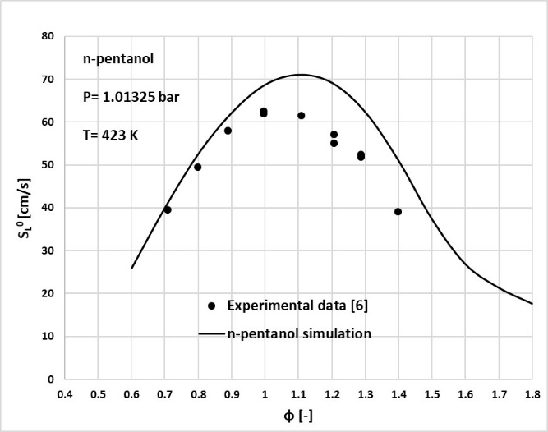

Figure 6. Experimental data and laminar flame speed simulation for n-pentanol/air mixture, p = 1 atm, T = 423 K. Experimental data: symbols; simulation: line.
Source: Authors’ own elaboration

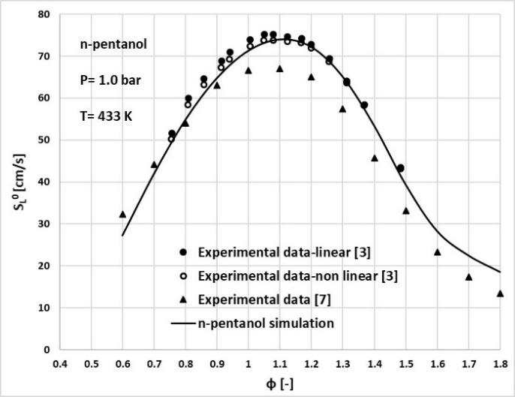

Figure 7. Experimental data and laminar flame speed simulation for n-pentanol/air mixture, P=1.0 bar, T=433 K. Experimental data: symbols; simulation: line. Source: Authors’ own elaboration

Figure 7 shows the comparison for p = 1.0 bar and T = 433 K. Two sets of experimental data are considered [3,7]. Considering experimental data reported by Nativel et al. [3], mean relative difference for linearized data is 2.87% and mean absolute difference is 1.83 cm/s. Respecting to non-linearized data, mean relative difference is 1.45% and the mean absolute difference is 0.87 cm/s, for 0.7 ≤ φ ≤ 1.5. Taking into account linearized and non-linearized experimental data jointly, mean relative difference is 2.16% and mean absolute difference is 1.35 cm/s. Based on the above, it is observed that there is a high agreement between results from simulation and these experimental data. In relation to the experimental data reported by Li [7], mean relative difference is 14.8% and mean absolute difference is 5.06 cm/s. Highest agreement is observed in the region of lean mixtures, φ < 1.0 (mean relative difference of 6.2% and mean absolute difference of 2.46 cm/s) and less agreement is observed in the region of rich mixtures, φ ≥ 1.0 (mean absolute difference of 6.21 cm/s and mean relative difference of 18.61%). It should be noted that even in the region of highest difference between results from simulation and experimental data, proposed reduced kinetic mechanism models very well the behavioral trend of experimental data. It is important to highlight that there are notable differences between the experimental data among themselves [3,7]. Furthermore, for conditions depicted in Figure 7, mean relative difference between results from simulation and the two experimental data sets [3,7] is 6.37% and mean absolute difference is 2.59 cm/s.

In summary, considering all the cases analyzed in this study, mean relative and mean absolute difference between values calculated by simulation applying developed reduced kinetic mechanism and experimental data are 7.01% and 2.93 cm/s, respectively. Lowest differences are presented with respect to the experimental data reported by Nativel et al. [3].

Conclusions

In this work, some chemical kinetic steps have been added to San Diego mechanism to simulate the generation of laminar flame of mixtures of n-pentanol/air and calculate its propagation speed. Adding 6 new species and 12 reactions to SD mech a reduced kinetic mechanism of 63 chemical species and 276 reactions have been developed. The present study also shows that combustion processes of n- pentanol can be modeled conserving the current reactions and reaction rates of base mechanism. To generate a useful short mechanism, R9 and R11 reactions represent overall effects through a steady-state approximation. It is important to highlight that selected chemical reactions and their corresponding rate parameters have been taken from literature without modification and application of developed reduced mechanism covers laminar flame speed predictions. Simulations results describe well laminar flame speed of n-pentanol/air mixtures at different temperatures and atmospheric pressure conditions respecting to the most referred experimental data, showing good agreement.

References

[1] Tanaka N. Technology Roadmap: Biofuels for transport. Int. Energy Agency, 2011:1-56

[2] Heufer K.A., Sarathy S.M. Curran H.J., Davis A.C., Westbrook C.K, Pitz W.J. Detailed kinetic modeling study of n-pentanol oxidation. Energy Fuels 2012; 26: 6678-85.

[3] Nativel D., Pelucchi M., Frassoldati A., Comandini A., Cuoci A., Ranzi E., Chaumeix N., Faravelli T. Laminar flame speed of pentanol isomers: An experimental and modeling study. Combustion and Flame 2016; 166:1-18.

[4] Bae C., Kim, J. Alternative fuels for internal combustion engines. Proc. Combust. Inst. 2017; 36: 3389-413.

[5] Gautam M., Martin D. Combustion characteristics of higher-alcohol/gasoline blends. Proc. Inst. Mech. Eng., Part A 2000; 214:497-511.

[6] Togbé C., Halter F., Foucher F. Mounaim-Rousselle C., Dagaut P. Experimental and detailed kinetic modeling study of 1-pentanol oxidation in a JSR and combustion in a bomb. Proc. Comb. Inst. 2011; 33:367-74.

[7] Li Q., Hu E., Zhang X., Cheng Y., Huang Z. Laminar flame speed and flame instabilities of pentanol isomer-air mixtures at elevated temperatures and pressures. Energy Fuels 2013; 27: 1141-50.

[8] Li Q., Tang C., Cheng Y. Guan L., Huang Z. Laminar flame speeds and kinetic modeling of n-pentanol and its isomers. Energy Fuels 2015; 29: 5334-48.

[9] Kelley AP, Law C.K. Nonlinear effects in tne extraction of laminar speeds from expanding spherical flames. Combustion and Flame 2009; 156: 1844-51

[10] Kelley A.P., Smallbone A.J., Zhu D.L., Law C.K. Laminar flame speeds of C5 to C8 n-alkanes at elevated pressures: experimental determination, fuel similarity, and stretch sensitivity. Proc. Comb. Inst. 2011; 33: 963-70.

[11] Köhler M., Kathrotia T., Oswald P., Fischer-Tammer M.L., Moshammer K., Riedel U. 1-, 2- and 3-Pentanol combustion in laminar hydrogen flames – A comparative experimental and modeling study. Combustion and Flame 2015; 162: 3197-209.

[12] Liu X., Wang H., Zheng Z., Liu J., Reitz R.D., Yao M. Development of a combined reduced primary reference fuel-alcohols (methanol/ethanol/propanols/butanols/n-pentanol) mechanism for engine applications. Energy 2016; 11 4:542-58.

[13] Wang G., Yuan W., Li Y., Zhao L., Qi F. Experimental and kinetic modeling study of n-pentanol pyrolisis and combustion. Combustion and Flame xxx (2015) xxx-xxx.

[14] Pelucchi M., Bissoli M., Rizzo C., Zhang Y., Somers K., Frassoldati A., Curran H., Faravelli T. A kinetic modelling study of alcohols operating regimes in a HCCI engine. SAE Int. J. Engines 10(5):2017.

[15] Ma Y., Huang R., Fu J., Huang S., Liu J. Development of a diesel/biodiesel/alcohol (up to n-pentanol) combined mechanism based on reaction pathways analysis methodology. Applied Energy 225 (2018) 835-847.

[16] Huang H., Lv D., Zhu J., Chen Y., Zhu Z., Pan M., Huang R., Jia C. Development and validation of a new reduced diesel/n-pentanol mechanism for diesel engine applications. Energy Fuels (2018).

[17] Katoch A., Alfazazi A., Sarathy S.M., Chauhan A., Kumar R., Kumar S. Measurement of laminar burning velocity of n-pentanol + air mixtures at elevated temperatures and a skeletal kinetic model. Fuel 237 (2019) 10-17.

[18] Pelucchi M., Namysl S., Ranzi E., Rodríguez A., Rizzo C., Somers K.P., Zhang Y., Herbinet O., Curran H.J., Battin-Leclerc F., Faravelli T. Combustion of n-C3-C6 Linear Alcohols: An Experimental and Kinetic Modeling Study. Part I: Reactions Classes, Rate Rutes, Model Lumping and Validation. Energy Fuels 2020, 34, 14688-14707.

[19] Li S., Zhang C., Jing Z., Li Y., Yin P., Cai P., Lu A. Development of a reduced chemical reaction mechanism for n-Pentanol based on combined reduction methods and genetic algorithm. ACS Omega 2021, 6, 6448-6459.

[20] The San Diego Mechanism, Chemical-Kinetic Mechanisms for Combustion Applications, UC San Diego, Combustion Research Grop, https://web.eng.ucsd.edu/mae/groups/combustion/mechanism.html

[21] Prince J.C., Treviño C., Williams F.A. A reduced reaction mechanism for the combustion of n-butane. Combustion and Flame 175 (2017) 27-33.

[22] H. Pitsch. FlameMaster: A c++ computer program for 0d combustion and 1d laminar flame calculations, https://web.stanford.edu/group/pitsch/FlameMaster.htm

